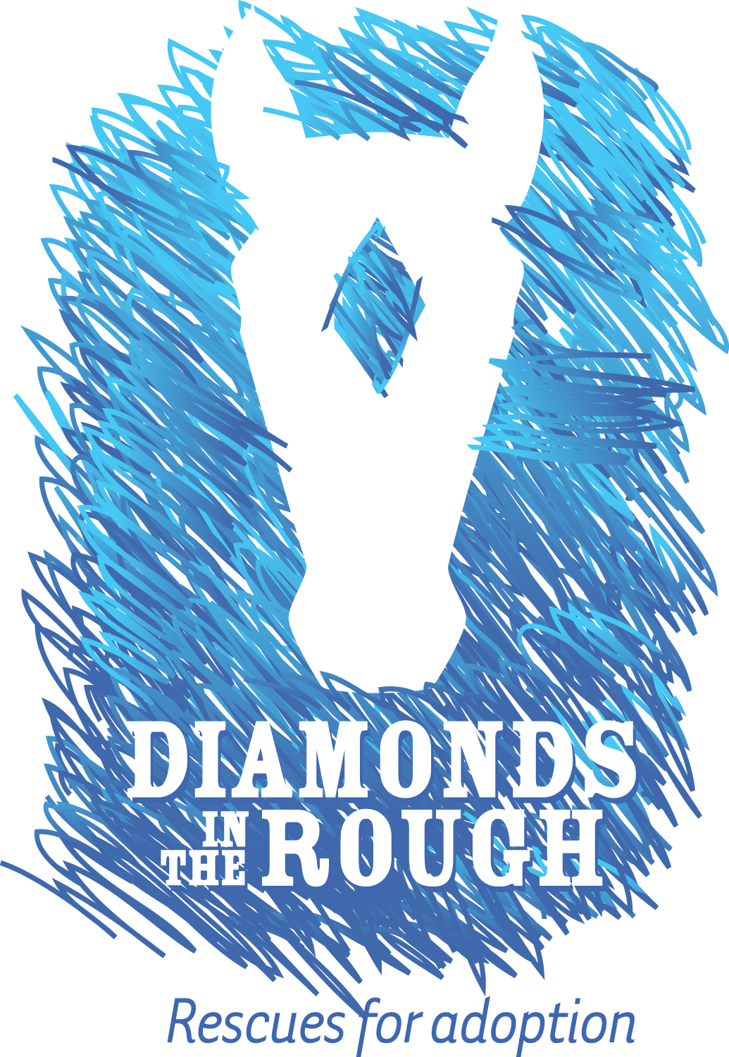
Adopters Name (must be at least 18 years of age_____________________________________
501(c)3 - #27-2524209

Diamonds In The Rough Rescue, Inc.
19251 Bob White Road
Windsor, Virginia 23487

Phone:
757-846-6076
757-642-8840

Email:
Sonja.DITR@gmail.com
Jennifer.DITR@gmail.com
Lisen.DITR@gmail.com
CherylC.DITR@gmail.com
Laura.DITR@gmail.com

Website:
www.AdoptDITR.org
www.facebook.com/AdoptDITR

Address (number, street):_______________________________________________________________ City, State, Zip: ________________________________________________________________
If equine is not being housed at the above address, list below the address where the horse will be kept: __________________________________________________________________
Home Phone: | Work Phone:
Cell Phone: | Email:
Equine Information:
Name: | Adoption Fee:
Breed: | Color:
Age: | Gender:
Height: | Weight:
The animal has been received in good condition to the best of our knowledge with the exception of any conditions noted: __________________________________________________________________________________________________________________________________________________________________________________________
Horse is to be picked up within 7 days or an additional boarding fee of $20 per day will be due.
Please understand that the details of this contract reflect our concern that both the new owner and adopted animal have a happy life together. The conditions set forth below have been based on years of experience. We feel that we have a continuing commitment to see that our rescued animals find a safe and happy permanent home. Considerable emotional involvement, time, money, and energy go into insuring that each of our rescued animals will have the best start in their new life. Diamonds In The Rough Rescue, Inc. and DITR are one and the same.
For and in consideration of the receipt of the above described animal, I, the above named adopter, agree to the following list of terms:
- This animal is a companion animal and is not being adopted for slaughter, factory farming, or resale. __________
- This animal is capable of riding and is not being adopted for slaughter, factory farming or resale. __________
- Upon signing this agreement, I agree to pay in full the monetary adoption fee in the amount of $__________, less the %50 percent deposit required to take this horse on trial. I agree to payment arrangements signed below.
- Understand all but $100 dollars will be refunded if the horse is returned within 30days _________

- A $50.00 late fee will be assessed for any monies not received per the agreed upon final payment date. The late fee will accrue on the first day of each month thereafter until payment is made in full. __________
- No refunds will be given after 30 days from date of adoption __________
- A $35.00 fee will be assessed for any returned checks. __________
- Any attorney fees or court costs incurred by Diamonds In The Rough Rescue, Inc, Sonja Reuter, or Merry Oaks Stables, LLC, as a result of non-payment, returned checks, breach of contract, and/or having to retake possession of a horse will be the responsibility of the above named adopter. __________
- To adopt, love, and provide reasonable care for the animal. To provide sufficient food, vitamins, and water to maintain a healthy body condition. To provide adequate shelter, farrier care, and humane treatment at all times. Adequate shelter shall be at a minimum a run in shelter with a roof and dry footing under cover. __________
- To have a Veterinarian visit at a minimum of once a year to have a coggins drawn, rabies shot, and dental work. Other shots to be given may be done by adopter or Veterinarian. All shots are to be kept up in the spring and fall. Regular de-worming and sand clear should be maintained for proper overall care of the horse. __________
- Failure to provide any care recommended by a veterinarian, farrier, and/or any other specialist shall be a breach of this contract and Diamonds In The Rough Rescue or any of its representatives may peaceably enter any property on which the animal is kept and reclaim it immediately. __________
- Any change of address with this animal will be required to let Diamonds In The Rough Rescue know of the new address: Email Information to Sonja.DITR@gmail.com or mail to DITR, 19251 Bob White Rd, Windsor, VA 23487. __________
- Diamonds In The Rough Rescue maintains ownership of the horse for 60 days from final payment date. At the 60 day date any paperwork for registration that we have will be given to the adopter and the horse may be sold free and clear with adopter’s choice. __________
- If the adopter cannot care for the horse within the 60 day period, DITR must receive horse back at adopter’s expense. The adopter then relinquishes all rights to DITR. __________
- DITR shall be named as an alternative contact on any boarding, veterinary care, or other contract regarding the animal within the 60 day period. This by no means deems DITR financially responsible. If the horse is returned within 60 days of the adoption date the adopter agrees all medical records can be released to DITR __________
- I agree to obey any and all animal control regulations governing the area in which I live. Failure to obey any state or local law regarding animal control and or welfare shall be deemed a breach of this contract. __________
- If I adopt a male animal that is too young to geld, I agree that the animal shall not be allowed any contact with females prior to being gelded. I further agree that said animal shall be gelded within 6 months or upon the dropping of both testes, by a veterinarian with full sedation. If the colt is a crypt orchid (fails to drop both testes by age one), I agree to have a veterinarian perform the necessary surgical procedure. __________
- Adopter shall give all necessary releases for DITR or any of its representatives to contact and obtain any records regarding the animal, including but not limited to veterinary, farrier, and police records. __________
- Except under extreme circumstances, if said animal is sick or injured, I will NOT have said animal euthanized without first consulting DITR even if I cannot afford to have it treated. __________
- I realize that every reasonable effort has been made to disclose the history of the animal as DITR knows it. These are rescued animals and in most circumstances DITR has little or no knowledge about the animal’s prior life or training. DITR has told me everything known about the animal: however, we cannot make any guarantees about an animal’s temperament or training. DITR is in no way responsible for the accuracy of information received about temperament, habits, or physical condition of the said animal that I am adopting. __________
- I herby give Diamonds In The Rough Rescue permission to provide my first name and a picture of me and my horse in the Success Stories of our website, Facebook, and other public places DITR deems appropriate regarding placement of the animal I am adopting. __________
- I understand that Diamonds In The Rough Rescue, Inc. and its representatives are not liable for any injury to or death of anyone as a result of any action of the adopted animal. Any animal carries an inherent risk. Adopter agrees to indemnify, defend, and hold harmless Diamonds In The Rough Rescue, Inc., its Volunteers, Board Members, and Officers from any liability resulting from this adoption. __________
- I understand that this contract is entered into in the Commonwealth of Virginia and will be interpreted and enforced under the laws of this state even if the animal lives in another state. __________
- Upon signing this contract, I acknowledge that I have read, understand and agree to be bound to Diamonds In The Rough Rescue, Inc.’s contract. __________
- A delivery fee of $0.75 per mile roundtrip will be charged to deliver or pick up an adopted horse. ______

Payment Terms:
Adoption Fee__________________________
Down Payment_______________________
Weekly Payment of __________________ for ______________weeks , starting ____________________.

________________________________________________________________________________________________________________________
Adopter’s Signature Date

________________________________________________________________________________________________________________________
Co-Adopter’s Signature Date
____________________________________________________________________________________________________________________
Diamonds In The Rough Rescue, Inc. Representative Signature________________________________Date____________

